User Manual for
Grievance Registration Of Government Employee (Jana Sunani)

Table Of Content

1 Grievance 4
1.1 Register Grievance 4

Grievance
In the Grievance Application, it provides a platform to register the grievance of the Government Employee. The respective government employee to register their grievance by proving the details and is further forwarded to the respective authority for verification.

Register Grievance
To register for the grievance, enter the website link in the browser and the page redirects to the External Grievance Portal (refer Fig. 1-1).
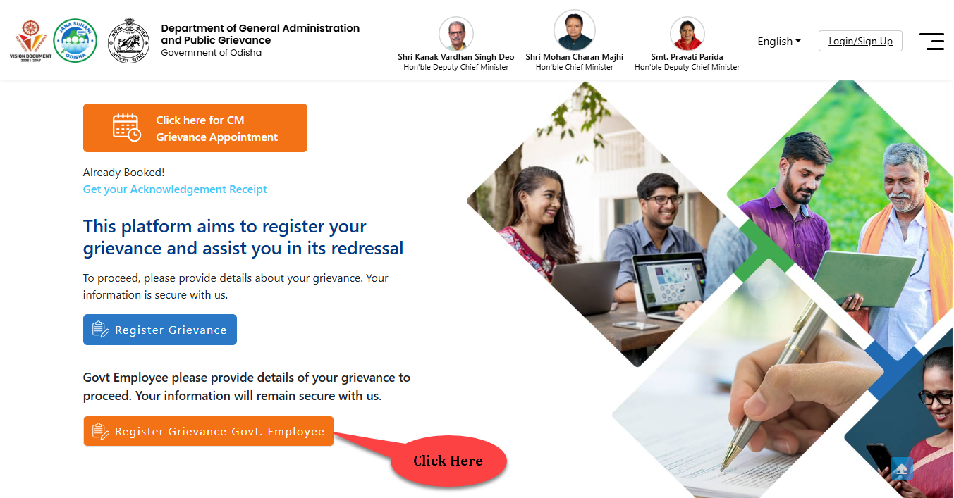
Figure 1-1 Welcome Screen
Referring to Fig. 1-1, in the Welcome screen-
- To register for the grievance, click on the Register Grievance Govt. Employee button as highlighted in the figure.
The page further navigates to Fig. 1-2.
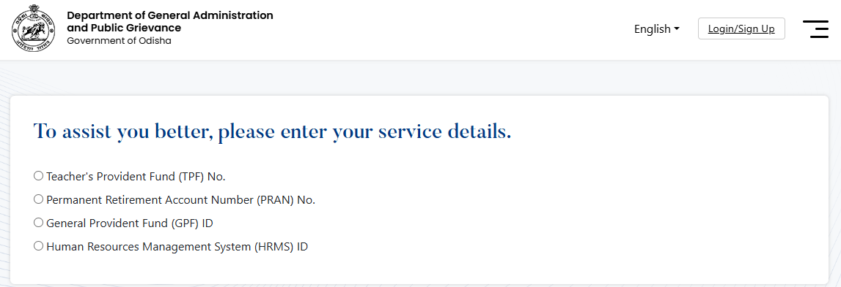
Figure 1-2 Grievance Screen
- Select the Service Number/ID by clicking against the radio button.
Further the page expands (refer Fig. 1-3).
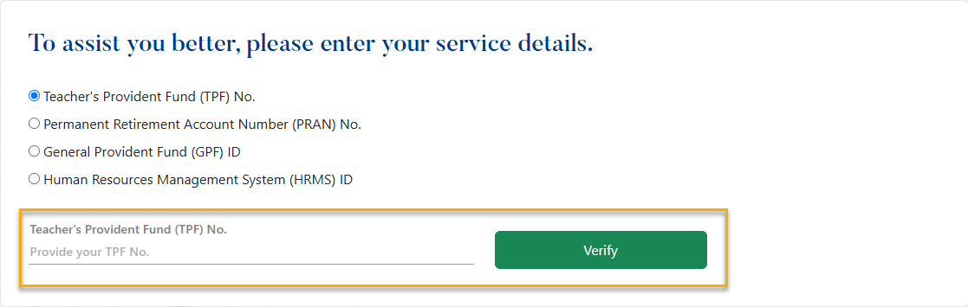
Figure 1-3 Grievance Screen
- Enter the Service Number/ ID (as per the selected service) in the text box field and click the Verify button.
Further a verification OTP pop-up populates in the screen (refer Fig. 1-4).
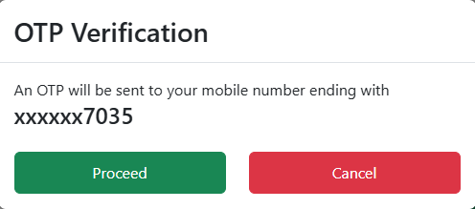
Figure 1-4 OTP Verification Screen (1)
Referring to Fig. 1-4, the OTP is sent to the verified mobile number of that government employee.
- For confirmation, click the Proceed button.
- Or to cancel the process, click the Cancel button.
Further to enter an OTP, a pop-up populates in the screen (refer Fig. 1-5).
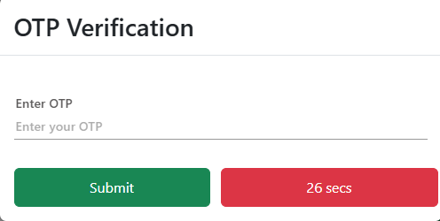
Figure 1-5 OTP Verification Screen (2)
- Enter the OTP in the text box field.
- Click the Submit button.
The page navigates to Fig. 1-6.
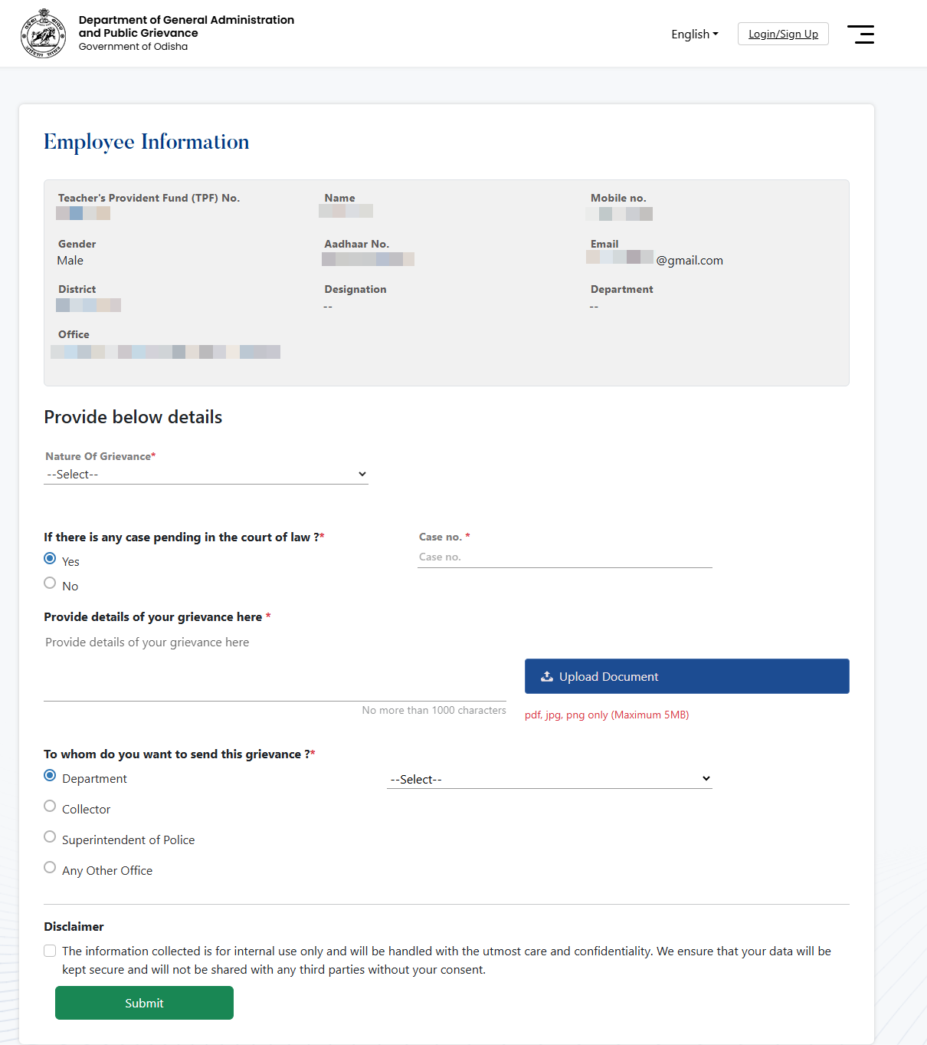
Figure 1-6 Registration Screen (1)
Referring to Fig. 1-6, in the Registration page, under the employee information section, it displays the detailed data of the employee- Name, Mobile No., Gender, Aadhaar Number, Email, District, Designation, Department and Office.
Under the Provide below Details section-
- Select the Nature of Grievance from the drop down menu.
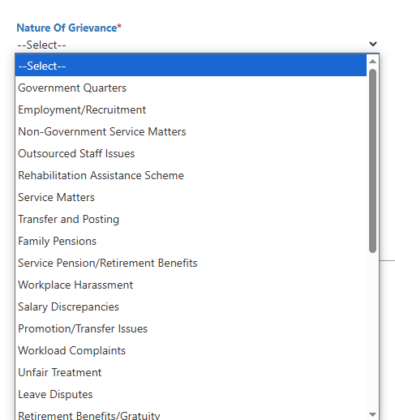
Figure 1-7 Registration Screen (2)
- Select Yes or No if there is any case pending in the court of law.
  - If selected as Yes, enter the Case No. in the text box field.
- Enter the Details Of The Grievance (within 1000 characters) in the text box field.
- Upload the Document (file must be of PDF/JPG/PNG format and within 5 MB size) by clicking on the Upload Document button.
Note: This section is not mandatory.
- Select to whom the grievance to be forwarded (Department, Collector, Superintendent of Police or Any Other Office) by clicking against the respective radio button.
  - After selecting, select the respective authority on the right side of the screen from the drop down menu (refer Fig. 1-8).
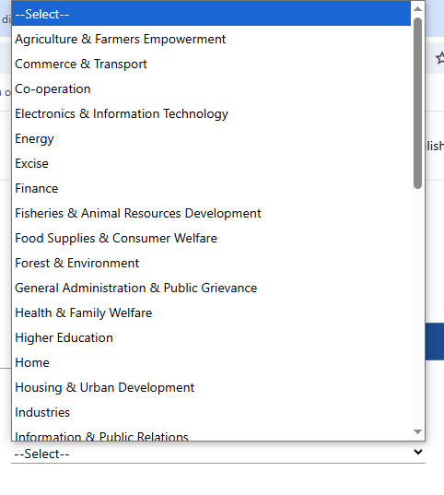
Figure 1-8 Registration Screen (3)
- For security purpose, click on the Disclaimer by selecting on the check box.
- Click on the Submit button.
Further a confirmation Alert pop-up populates in the screen (refer Fig. 1-9).

Figure 1-9 Confirmation Alert Pop-up
Referring to Fig. 1-9-
- To confirm the registration, click the Yes button.
- To cancel the registration, click the No button.
Further the page navigates to the confirmation page (refer Fig. 1-10).
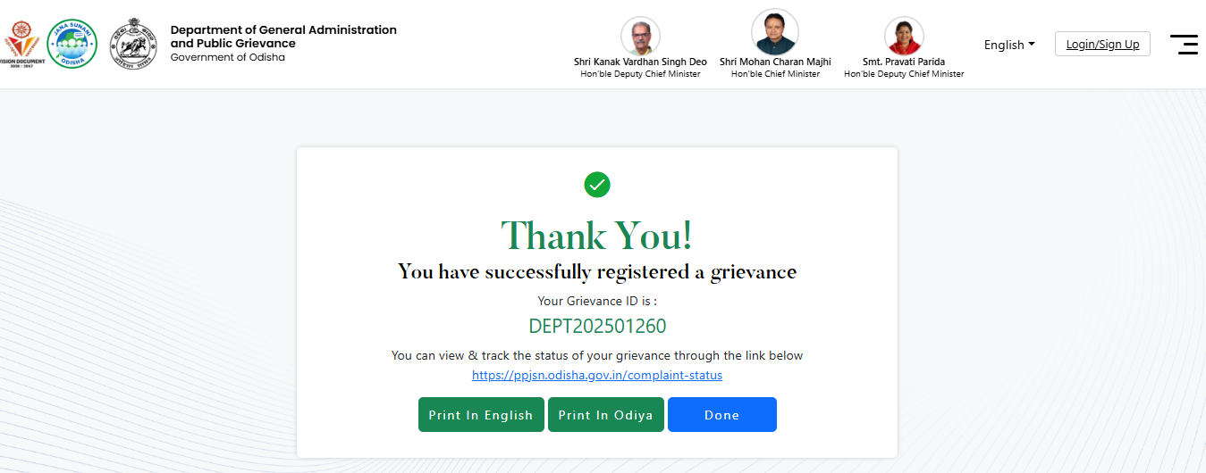
Figure 1-10 Confirmation Screen
Referring to Fig. 1-10, in the Confirmation page, it displays the details of the applied grievance application.
- To view and track the status of the grievance, a link is provided.
- To print the grievance in the English or Odiya, click on the Print In English/ Print In Odia.
- To close the screen, click on the Done button.

Table of Figures
Figure 1-1 Welcome Screen 3
Figure 1-2 Grievance Screen 3
Figure 1-3 Grievance Screen 4
Figure 1-4 OTP Verification Screen (1) 4
Figure 1-5 OTP Verification Screen (2) 5
Figure 1-6 Registration Screen (1) 6
Figure 1-7 Registration Screen (2) 7
Figure 1-8 Registration Screen (3) 8
Figure 1-9 Confirmation Alert Pop-up 8
Figure 1-10 Confirmation Screen 9

