Training Manual for
Jana Sunani
CM Grievance Appointment

- Enter the website URL https://janasunani.odisha.gov.in/ in the browser to land onto the following page.
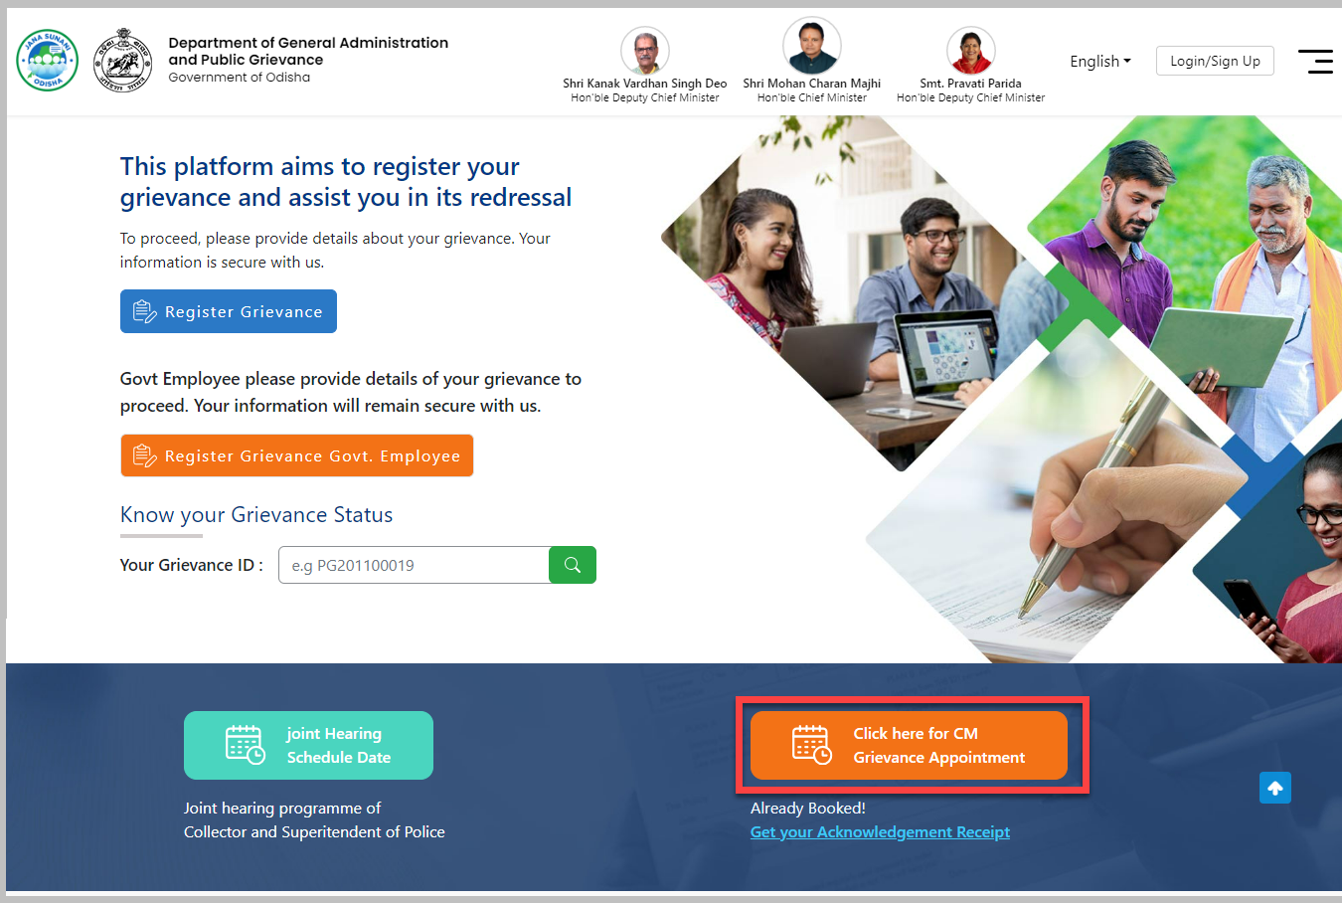
- To schedule a grievance appointment with the CM, click the Grievance Appointment button as highlighted in the figure above.
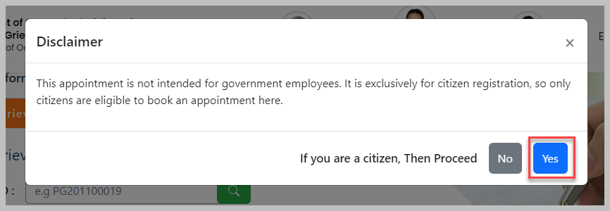
- You will get a Disclaimer informing that the appointment is not meant for the government employees. This provision is exclusively meant for the non-government citizens.
  - In case of a non-government citizen, to proceed further click the Yes option, else click the No option.
- On proceeding further, the dates available for CM grievance appointment are displayed along with the Slot availability and Venue.
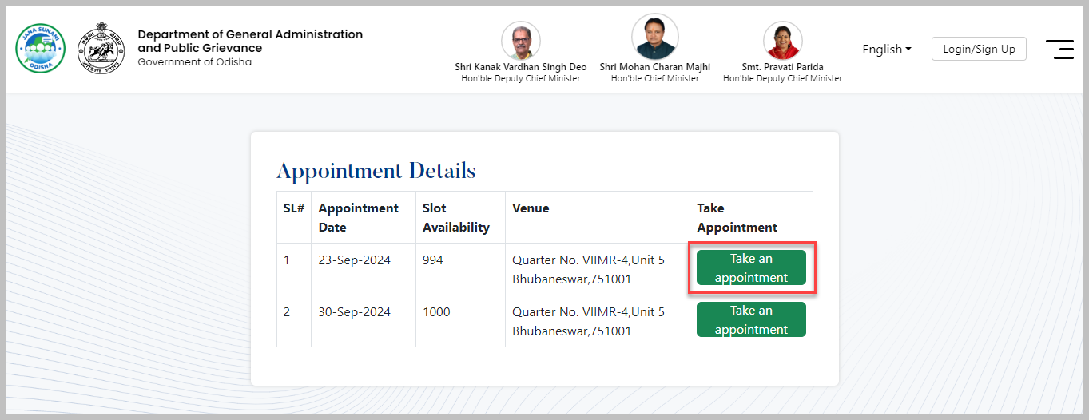
- On choosing the appointment date, you are redirected to the Appointment details screen wherein you need to fill-in all the personal details and the subject of your grievance in the respective fields-
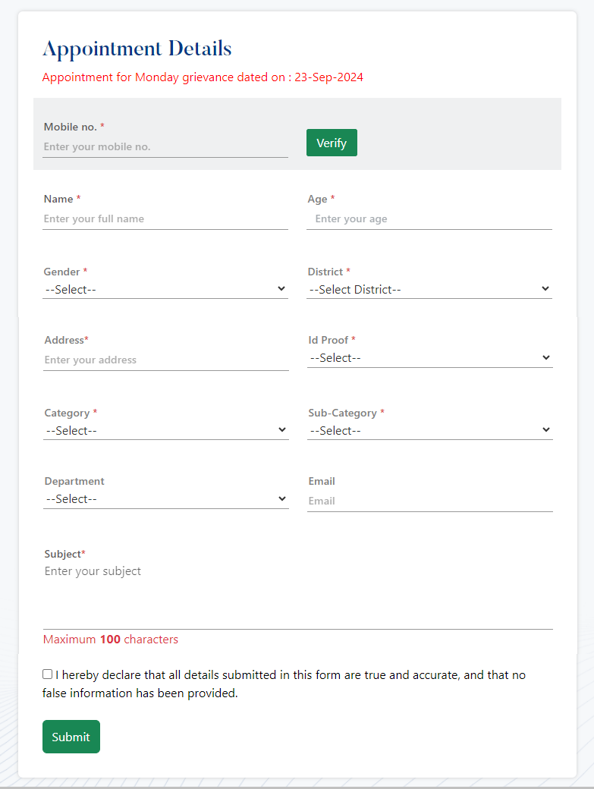
  - Enter the registered Mobile number in the textbox given which should have the Whatsapp access.
    - Click the Verify button.
    - An OTP is fired to the mobile number.
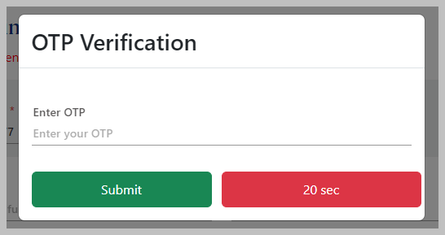
    - Enter the 6-digit OTP received in the textbox and Submit it.
    - Once the correctness of the OTP is checked, the status appears as Verified.
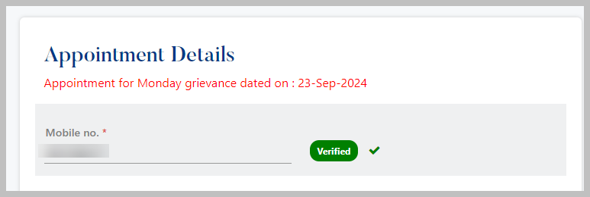
  - Enter your full Name in the textbox followed by your age.
  - Select your Gender from the drop down menu either as Male, Female, Transgender or Others.
  - Select the name of the District to which you belong from the list.
  - Mention your Address in the space given as per the district chosen.
  - Select the type of Id Proof to be provided at the meeting venue from the menu list.
  - Enter the number of the id proof as chosen.
  - Select the type of Category and Sub-Category from the respective menu list to which the grievance belongs.
  - Select the Department name to which grievance is associated.
  - Provide your Email Id for communication purpose.
  - Enter the Subject of your grievance with a maximum word limit of 100 characters.
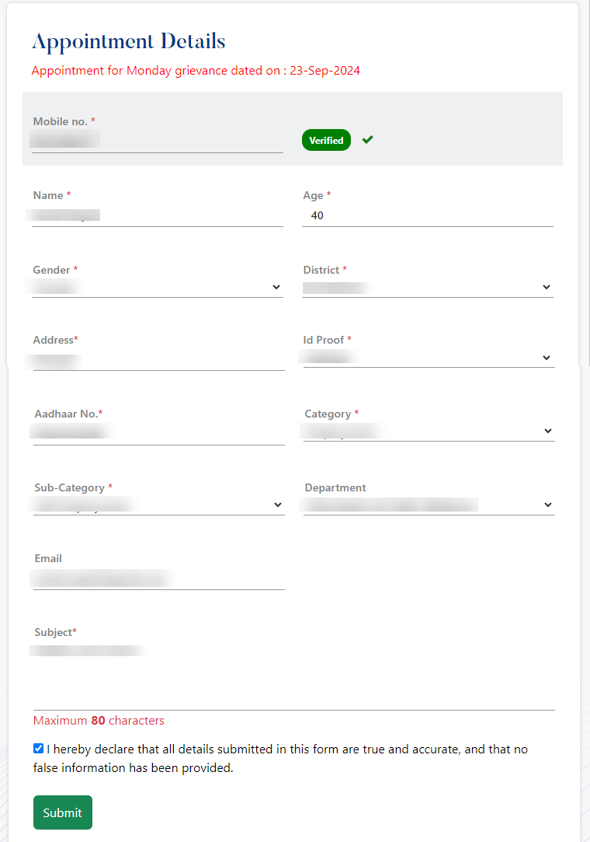
  - Select the checkbox to agree by the declaration that the details submitted in this form are true and accurate in all respects.
  - Click the Submit button.
- Once the application is submitted successfully, you will receive an Acknowledgement No. which can be retained for further use.
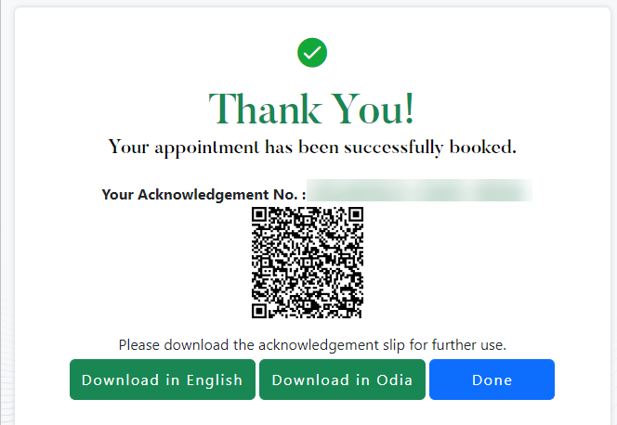
- Here you have an option to download the acknowledgement slip both in English and Odia.
- You need to provide this acknowledgement slip at the time of visiting the meeting venue on the date and time scheduled.
  - ID proof as mentioned in the form needs to be provided along with this slip.
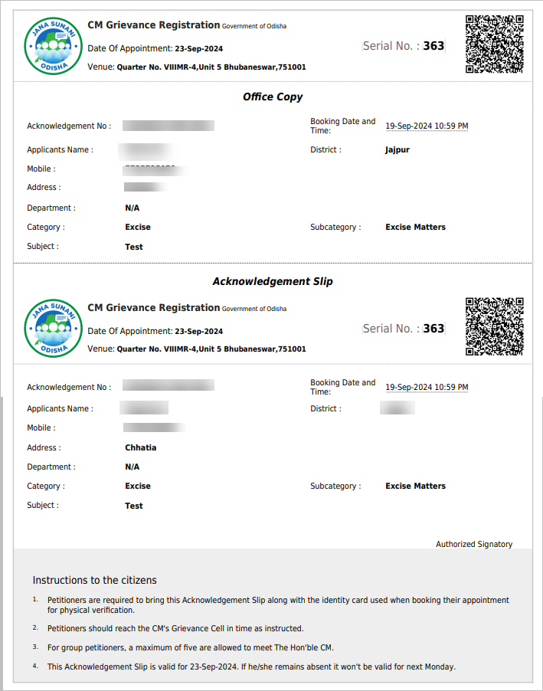
- If you have already booked for the appointment, then to know the status of the application, click the Get your Acknowledgement Receipt link in the home page as highlighted below-
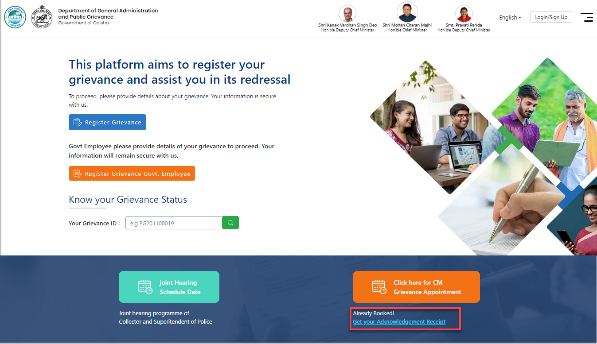
- A pop-up box will open wherein you can enter your acknowledgment number generated to get the status.
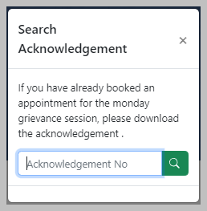
Please Note: If you met the CM on the scheduled date, then you can’t apply for the next meeting within a time span of 3 months.
In case the appointment is fixed but you were not able to attend it, then you can schedule the next appointment for the next slot available.

